**Red Teaming: Breaking Things on Purpose (and Getting Paid for It)**

Meta: If hacking stuff, finding flaws, and embarrassing security teams (ethically) sounds fun, Welcome. This is Red Teaming, and it’s not just “fancy pen testing.”



Photo by [Towfiqu barbhuiya](https://unsplash.com/@towfiqu999999?utm_source=medium&utm_medium=referral) on [Unsplash](https://unsplash.com/?utm_source=medium&utm_medium=referral)

**1. What Is Red Teaming?**

Imagine if you hired someone to break into your house just to prove your locks suck. That’s red teaming.

But unlike your cousin who tested your front door with a credit card, Red Teaming is structured, authorized, and terrifyingly effective

At its core, *Red Teaming is adversarial simulation.*You mimic real-world attackers, their methods, their tools, their dirty tricks and find out if your defenses are anything more than a suggestion (or is entirely useless)

**2. Red vs. Blue vs. Purple: Who’s on Which Side?**

Let’s understand the cyber color war:

* **Red Team**: Offensive - break in, stay hidden, make defenders sweat.
* **Blue Team**: monitor, detect, respond, try not to cry.
* **Purple Team**: Peace negotiators - help both sides learn from each other without starting WWIII.

If cybersecurity were a ***movie***:

* **Red Team** = heist crew
* **Blue Team** = bank security
* **Purple Team** = film director making sure the shoot goes smoothly

**3. What Red Teams Actually Do (It’s Not Just Hacking Wi-Fi at Starbucks)**



Photo by [Growtika](https://unsplash.com/@growtika?utm_source=medium&utm_medium=referral) on [Unsplash](https://unsplash.com/?utm_source=medium&utm_medium=referral)

Red teaming isn’t just a 30-minute scan and report.

It’s an *end-to-end operation* that might take weeks or months.

Here’s what’s typically involved:

***A. Reconnaissance***

* Stalk the target online like it owes you money.
* Google dorking, OSINT, LinkedIn creeping, dumpster diving (optional but thrilling).
* Tools: Maltego, SpiderFoot, the company’s forgotten careers page from 2009.

***B. Initial Access***

* Phishing emails with just the right amount of urgency (“Your HR password expired!”).
* Exploiting known vulnerabilities.
* USB drops (yes, people ***still*** plug them in).

***C. Privilege Escalation***

* From “intern” to “domain admin” in five easy steps.
* Abusing weak permissions, password reuse, or misconfigured servers.
* **Bonus**: Dumping password hashes.

***D. Lateral Movement***

* You’re in, now start crawling.
* Use RDP, SMB, WMI, PSExec to spread across the network like a gossip in a small town.
* Hide in plain sight. The best Red Teamers are digital ninjas.

***E. Persistence***

* Establish your secret backdoors: scheduled tasks, registry keys, credential theft, or good old C2 beacons.

***F. Action on Objectives***

* Steal the crown jewels (not literally, unless it’s the …).
* Exfiltrate data, demonstrate impact, screenshot everything.
* **Bonus**: Drop a “proof.txt” file on the CEO’s desktop. Classic taunt.

**4. The Mindset: Think Like an Attacker (But Little Smarter)**

Red Teaming isn’t just about tools, it’s about *thinking like the enemy*. Creativity > automation.

***Ask yourself:***

* “If I were malicious, where would I start?”
* “What’s the easiest way in with the least noise?”
* “How can I blend in with regular user behavior?”

Red teaming rewards curiosity, patience, and being deeply paranoid in creative ways.

**5. Red Team ≠ Penetration Test**

Let’s break this myth similar to a bad router config.

Red Teaming vs Pen Testing

Think of pentesting as checking for open windows. Red teaming is seeing if you can sneak in, steal the TV, and leave a note in the fridge.

**6. Real-World Red Team Tactics (Yes, They Happen)**



Photo by [Glen Carrie](https://unsplash.com/@glencarrie?utm_source=medium&utm_medium=referral) on [Unsplash](https://unsplash.com/?utm_source=medium&utm_medium=referral)

* Phishing campaigns that spoof HR or IT support.
* Malicious browser extensions to harvest cookies.
* Rogue Wi-Fi hotspots in company cafeterias.
* Cloning employee badges via RFID skimming.
* Abusing cloud misconfigurations (hello S3 buckets).

Red teams often find what everyone else missed, the human flaws, the oversights, the backdoors left open because *it’s just staging.*

**7. Red Team Tool Belt: What’s in the Arsenal?**

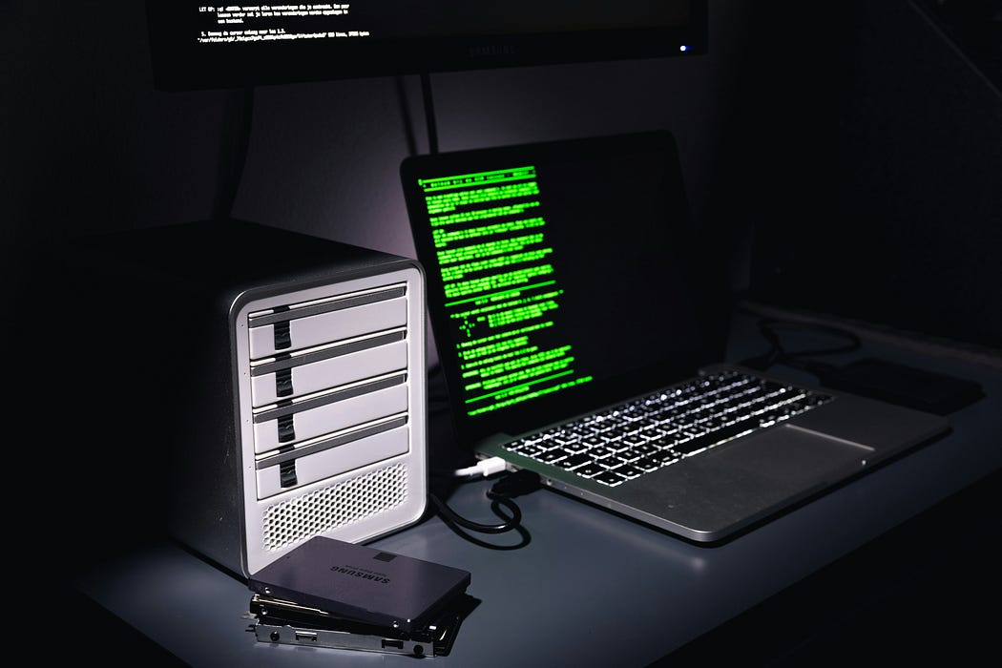

Photo by [Rohan](https://unsplash.com/@rohanphoto?utm_source=medium&utm_medium=referral) on [Unsplash](https://unsplash.com/?utm_source=medium&utm_medium=referral)

You’ll need more than Kali Linux and caffeine. Here’s the basic toolkit:

**A. Recon & OSINT**

* Recon-ng, theHarvester, Maltego
* Google (yes, seriously)

**B. Initial Access**

* **Phishing frameworks:** GoPhish, Evilginx
* **Exploits:** Metasploit, custom payloads

**C. Post-Exploitation**

* **C2 Frameworks**: Cobalt Strike, Mythic, Sliver
* **Privilege Esc:** Mimikatz, PowerUp, SharpHound
* **Lateral Movement**: Impacket, CrackMapExec, BloodHound

**D. Reporting (because yes, you have to)**

* Screenshots. Logs. More screenshots. Impact summaries. Executive-friendly graphs with scary red arrows.

**8. Red Team Ethics: Legal… Very Legal**

Red Teaming without permission is **illegal**. Period.



Photo by [Scott Graham](https://unsplash.com/@amstram?utm_source=medium&utm_medium=referral) on [Unsplash](https://unsplash.com/?utm_source=medium&utm_medium=referral)

You need:

* Explicit written authorization (Rules of Engagement)
* Defined scope
* Boundaries (no ransomware “just for fun”)

Red teaming is legal hacking with strict rules. Break them and you’re no longer a Red Teamer, rather you’re an episode of ***CSI: Cyber***.

**9. Learn Red Teaming**



Photo by [Ling App](https://unsplash.com/@lingapp?utm_source=medium&utm_medium=referral) on [Unsplash](https://unsplash.com/?utm_source=medium&utm_medium=referral)

**Want to Learn Red Teaming?**Here’s How to Start:

* **Build your fundamentals**: Networking, Linux, Windows internals
* **Get hands-on**: HackTheBox, TryHackMe, Offensive Security Labs
* **Certs** (if you’re into that): OSCP, CRTO, Red Team Ops, PNPT
* **Read**: Red Team Field Manual, MITRE ATT\&CK, and actual reports from real red teams

**10. Red Teaming Isn’t Glamorous**

There’s a lot of:

* Waiting for payloads to call back
* Writing reports
* Getting detected by an overzealous AV
* Explaining to managers that “yes, you ***allowed*** us to do this”

But it’s also:

* Exhilarating
* Impactful
* Incredibly satisfying when done right

**TLDR (But Make It Red)**

* Red Teaming = Ethical attacker simulation.
* It’s stealthy, structured, and way more than just a pentest.
* Real skill lies in blending creativity with technical prowess.
* Always operate ethically. Or don’t and enjoy prison Wi-Fi.

**Test Yourself?**

1. What’s the main goal of Red Teaming?

a) List all CVEs  
b) Cause panic  
c) Simulate real-world attackers  
d) Flex tools on LinkedIn

2. Which tool is used for command & control (C2)?

a) Wireshark  
b) Cobalt Strike  
c) Paint  
d) PuTTY

3. What’s the first step in a red team engagement?

a) Exploitation  
b) Reporting  
c) Reconnaissance  
d) Ask ChatGPT

*(Answers: 1c, 2b, 3c)*

**Enjoyed the read?**  
Smash the follow button, drop a comment, and share this with someone who still thinks “password” is a good password.